**TASK#1**

Prompt:# Generate a Python script that collects user data (name, age, email).  
 # Add comments on how to anonymize or protect this data

Output:

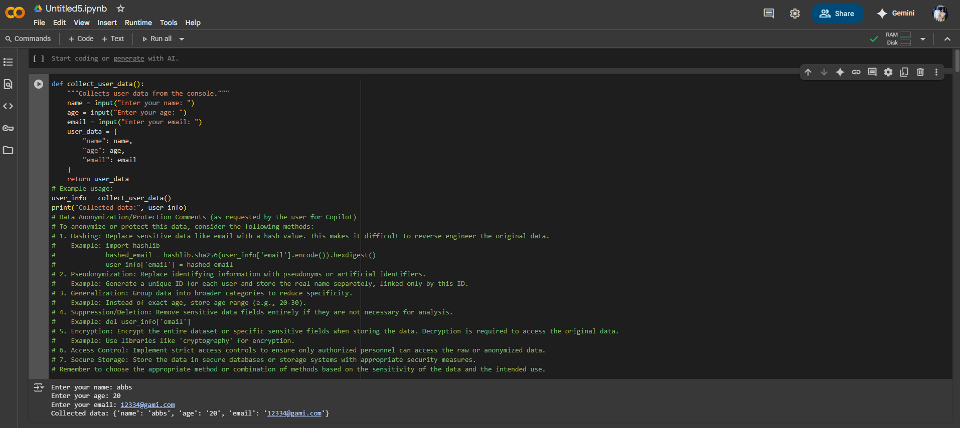

**Task#2**

Prompt: # Generate a Python function for sentiment analysis  
 # Add comments on how to identify and handle potential biases in the sentiment data.

Output:

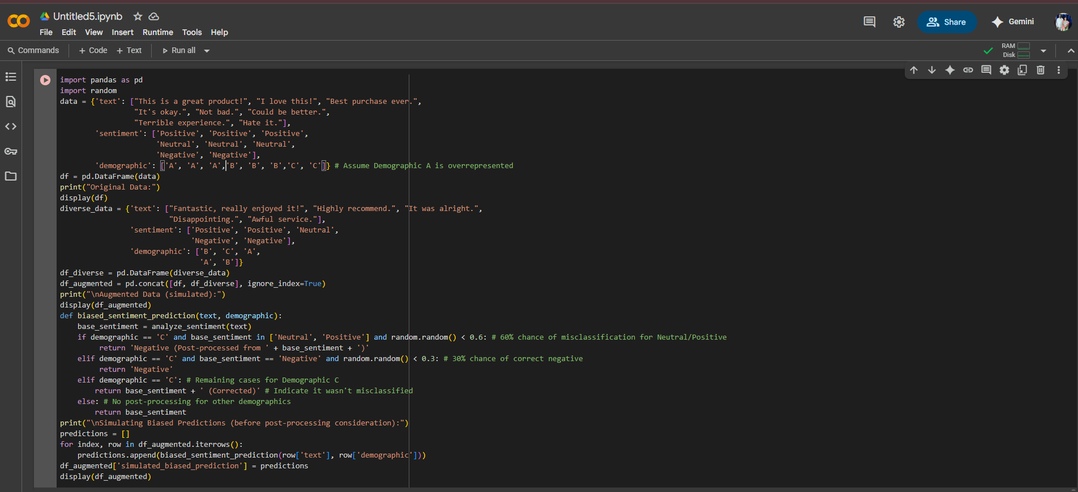



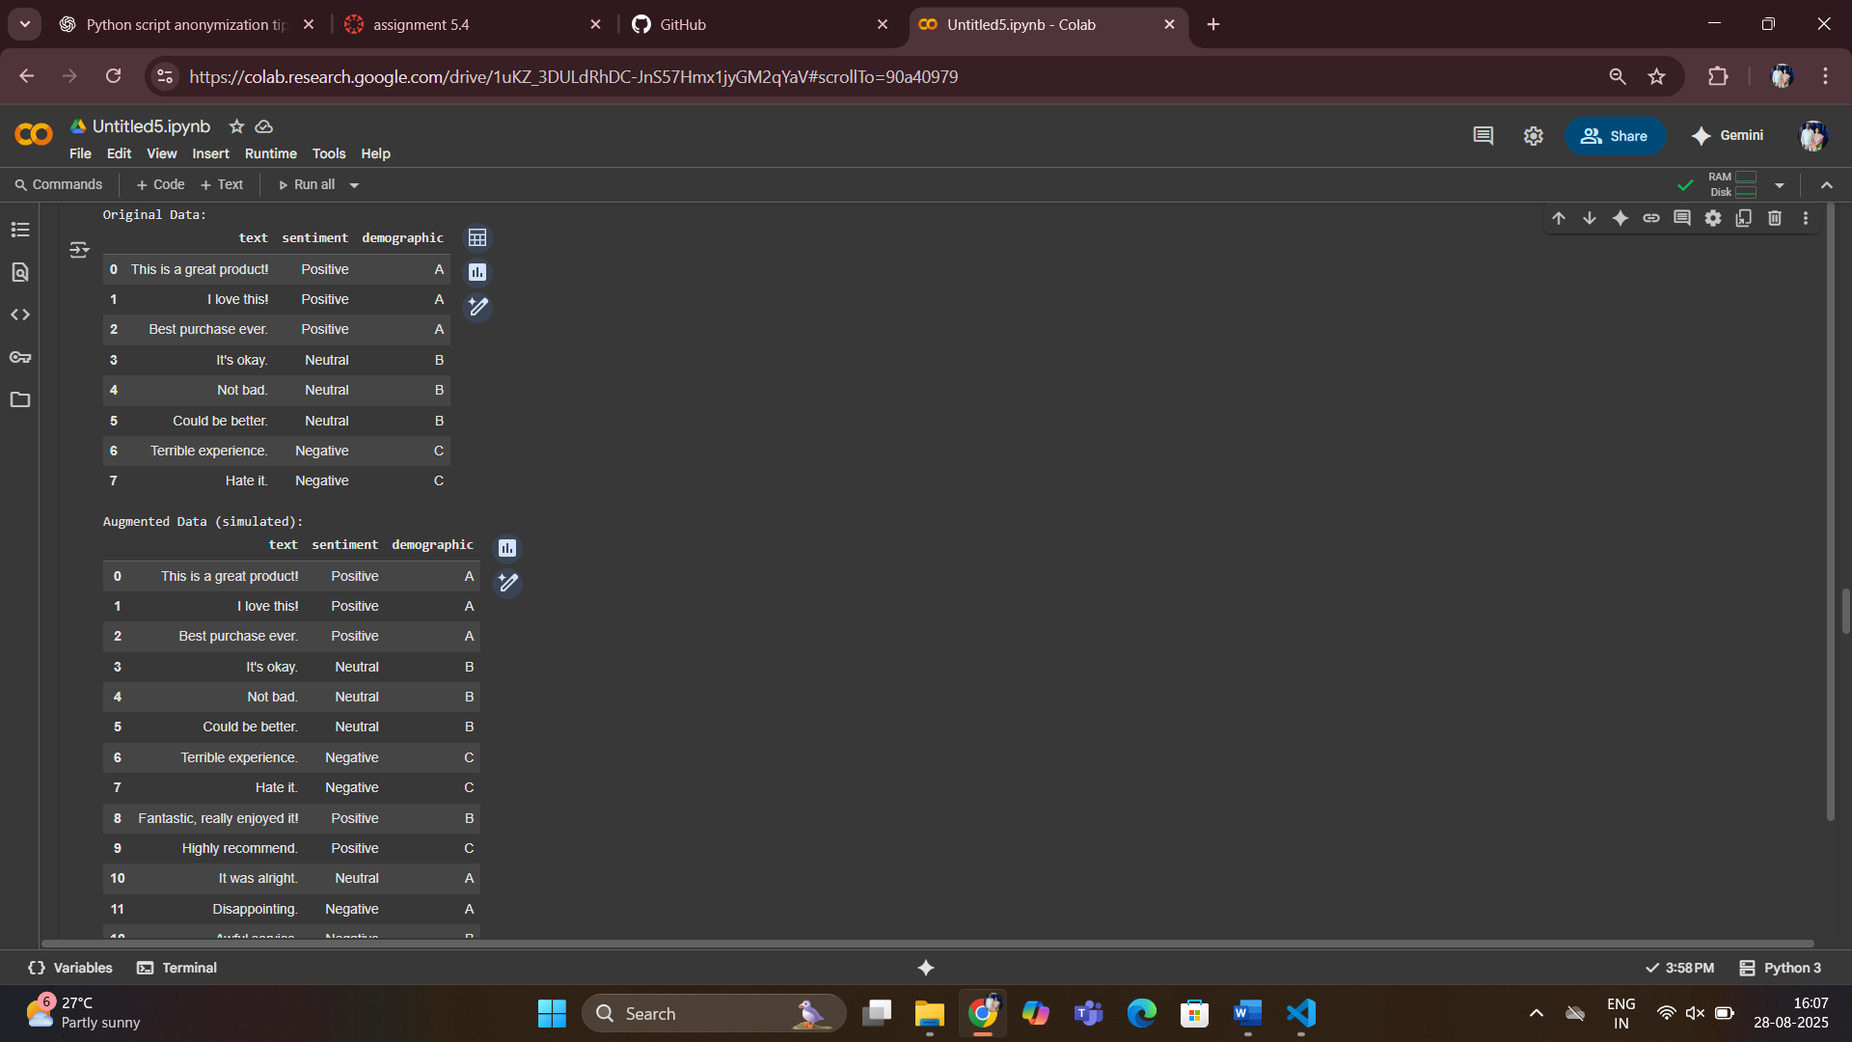

**Task#3**  
  
Prompt :# Write a Python program that recommends products to users based on their history  
 # Add ethical guidelines like transparency, fairness, and user feedback options  
  
Output:

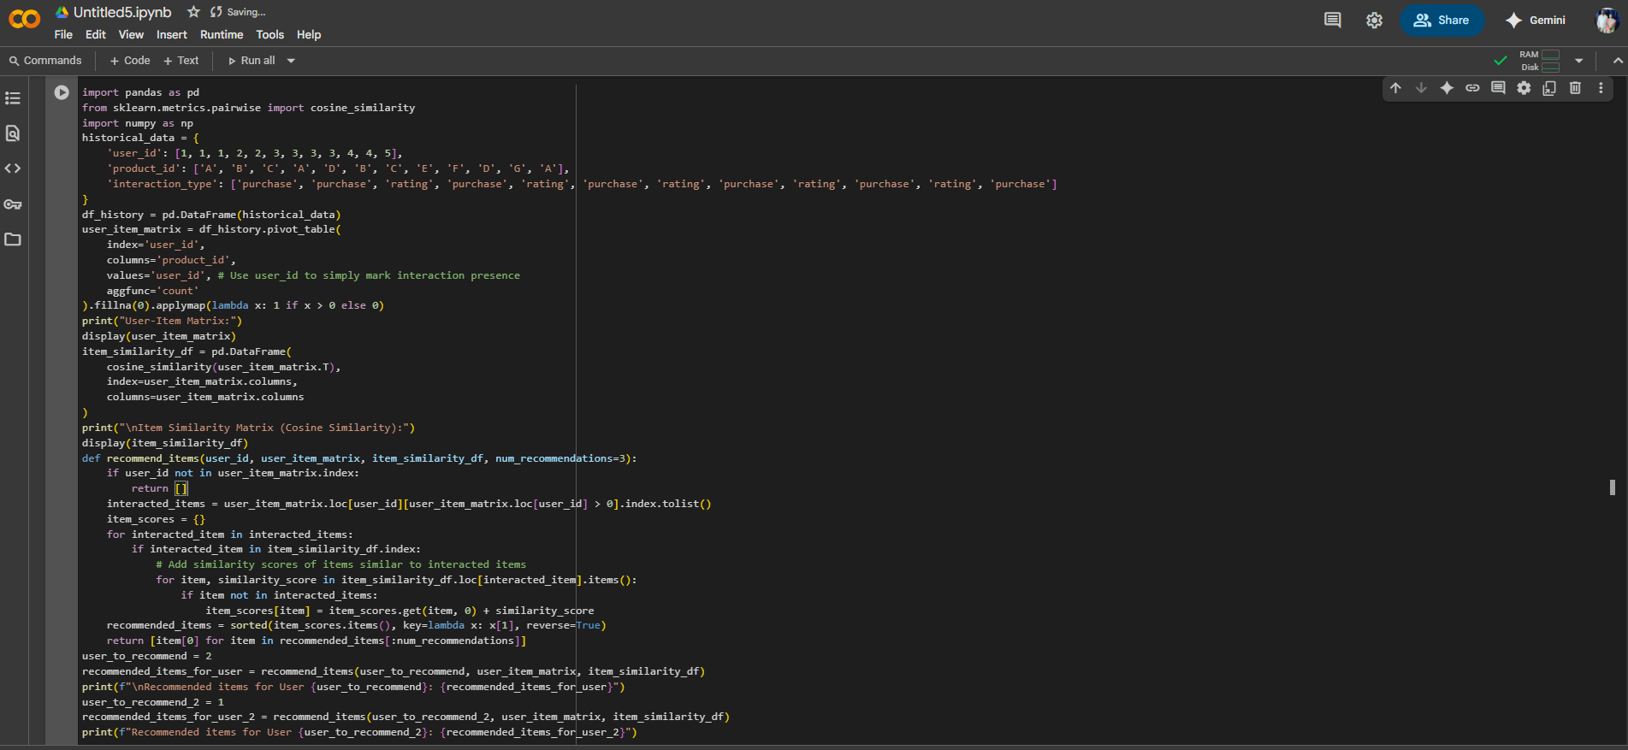

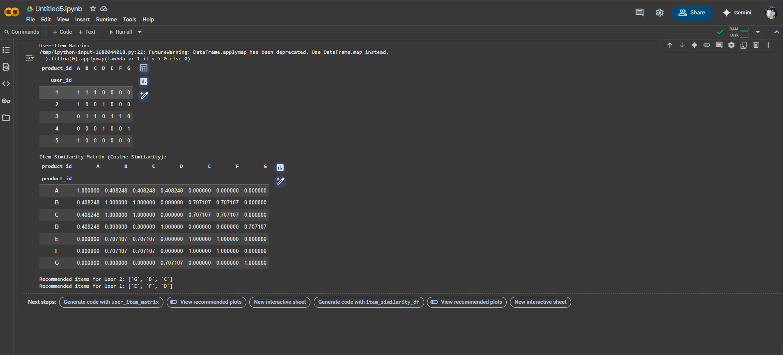

**Task#4**

Prompt: # Generate logging functionality in a Python web application.

# Ensure logs do not record sensitive information like passwords or emails

# Add comments about ethical logging practices.

Output:

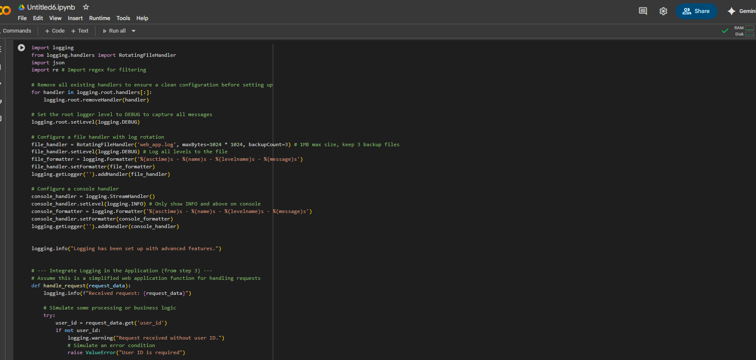 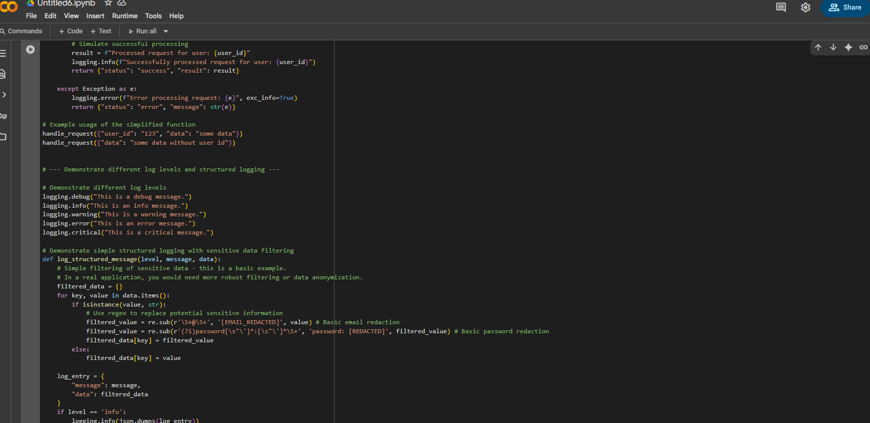

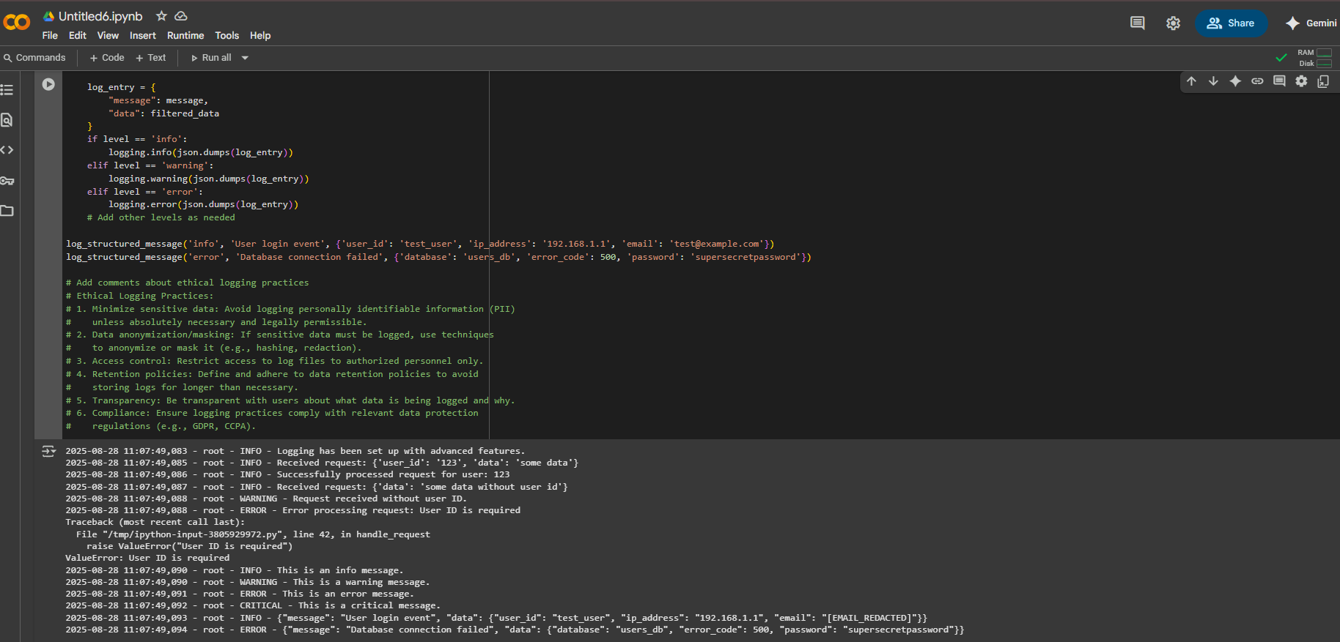

**TASK#5**

Prompt: # Generate a simple machine learning model in Python.

# Add documentation about responsible usage of this model:

# - Explainability

# - Accuracy limits

# - Fairness considerations

Output:

